Title: Water Tank Filling and Emptying Control System.
Objectives:
- To simulate a physical process by using an addition and subtraction counter to represent liquid volume.
- To use comparator instructions to generate virtual sensor signals.
- To pump water into tank when water level is low and pump out the water when tank is full.
System Description:
This system simulates a water tank with two pumps: a Fill Pump (pump1) and a Drain Pump (pump2). Because this is a software simulation, there are no physical liquid sensors. Instead, the PLC uses mathematical logic to simulate the tank level.
When the Fill Pump is ON, a counter increments to simulate water entering the tank. When the Drain Pump is ON, the same counter decrements to simulate water leaving. A Scaler block converts this counter value into 0 to 100 scale reading. Comparators evaluate this reading to act as level sensors Low, Mid, High and Full. These virtual switches control the physical Start/Stop latching of the two pumps, creating a continuous fill-and-drain cycle.
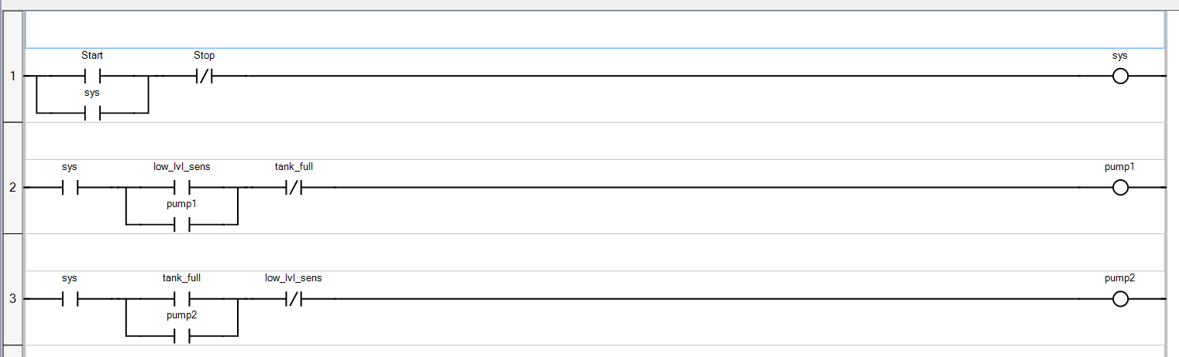
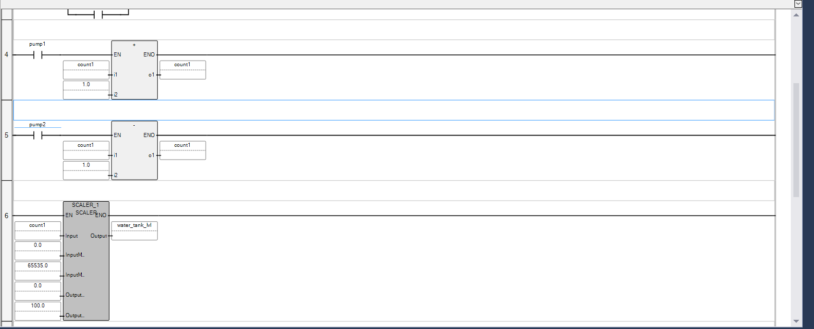
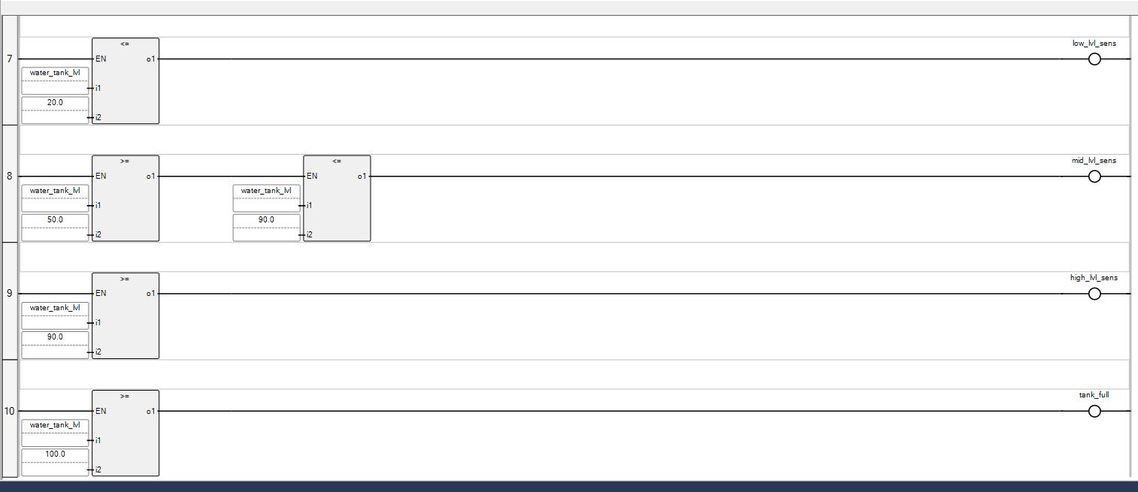
The Variables of the systems are:
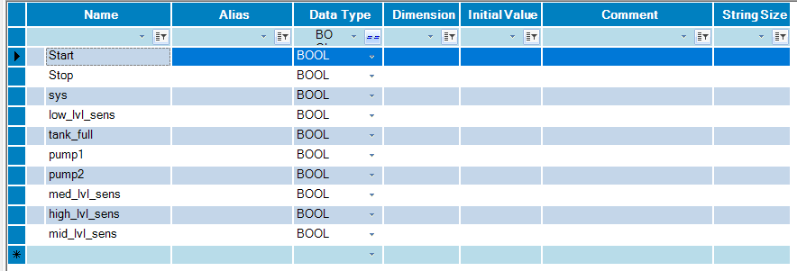
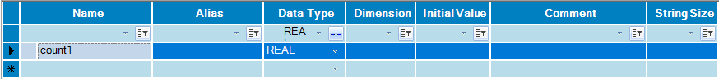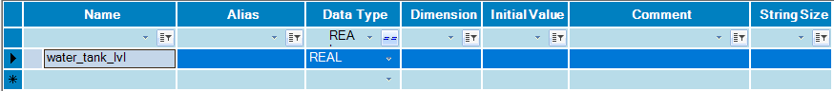
The input/ouput (I/O) mapping is:
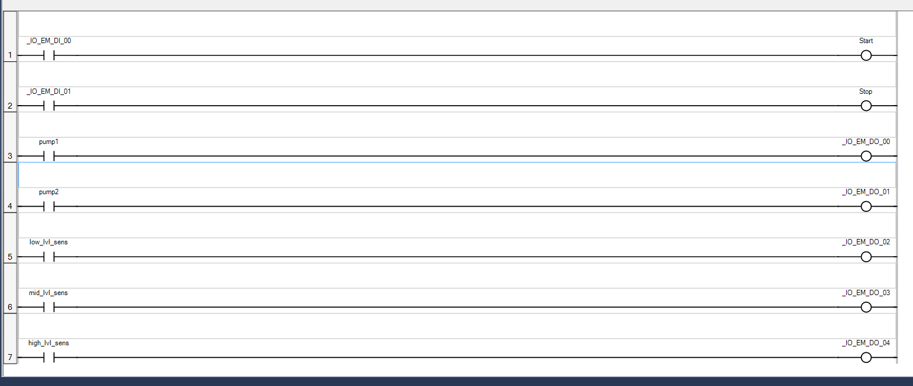
Output:
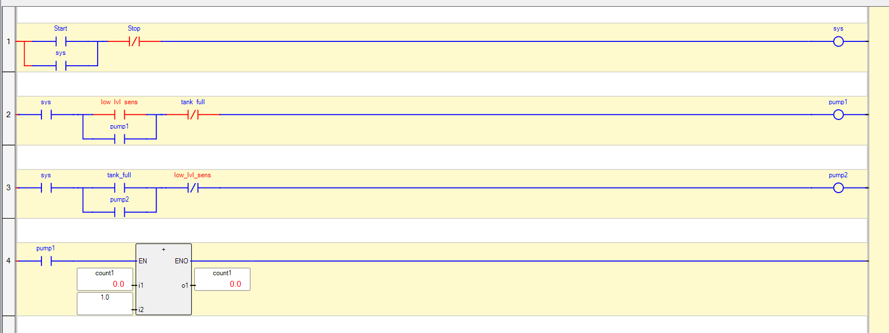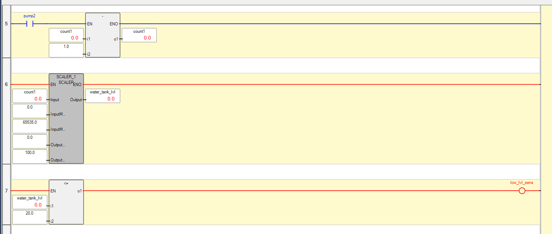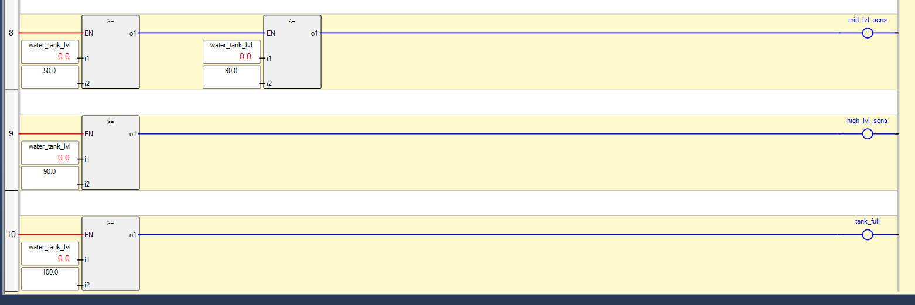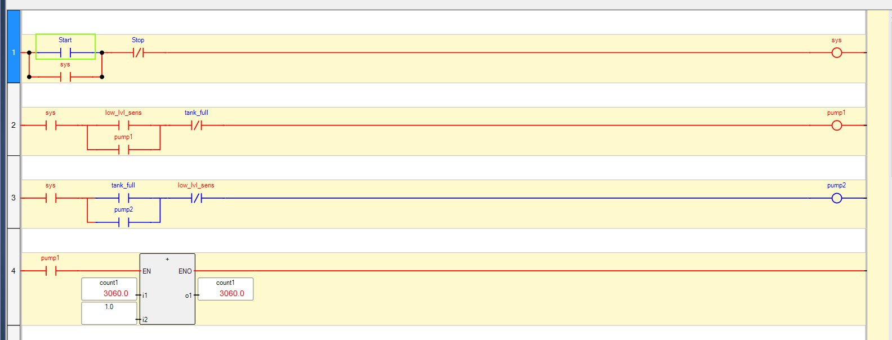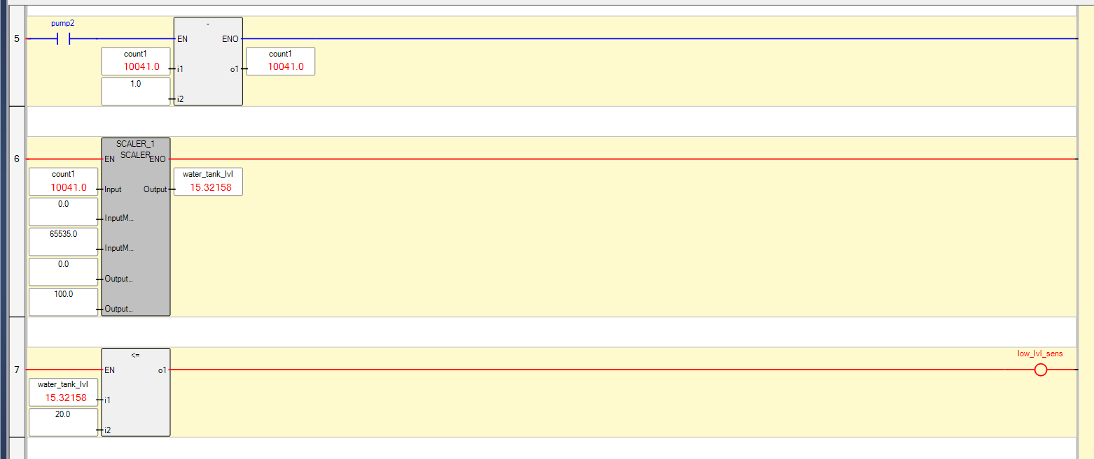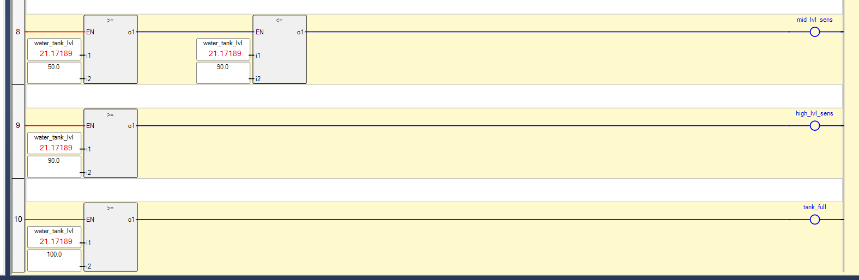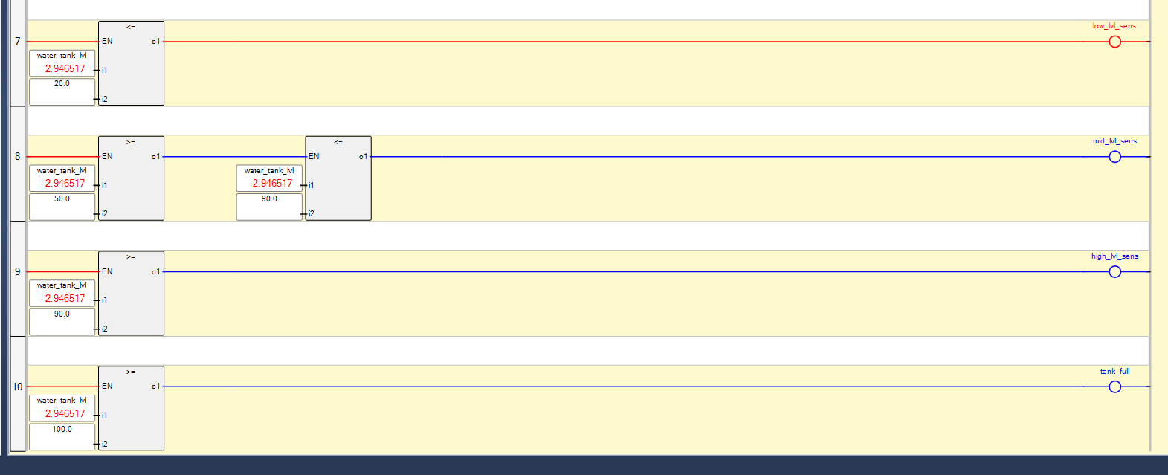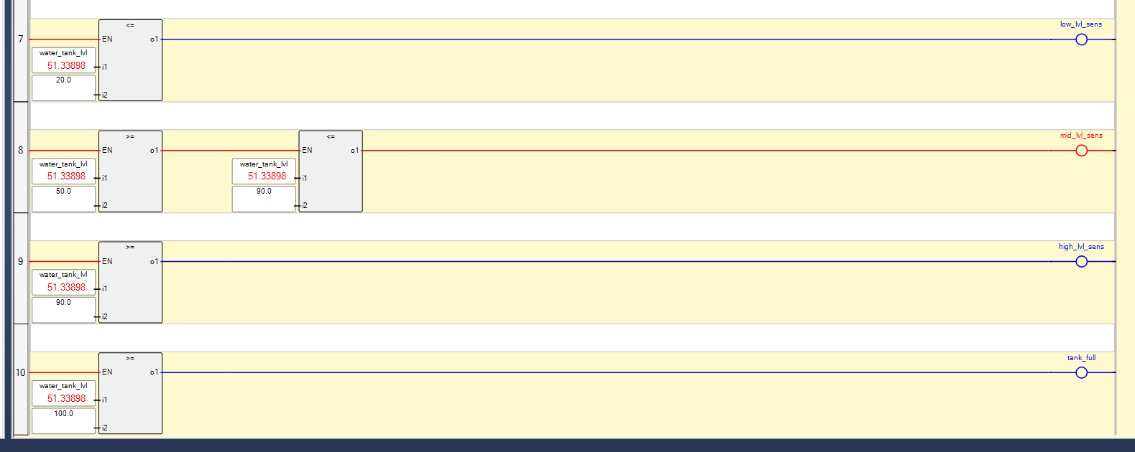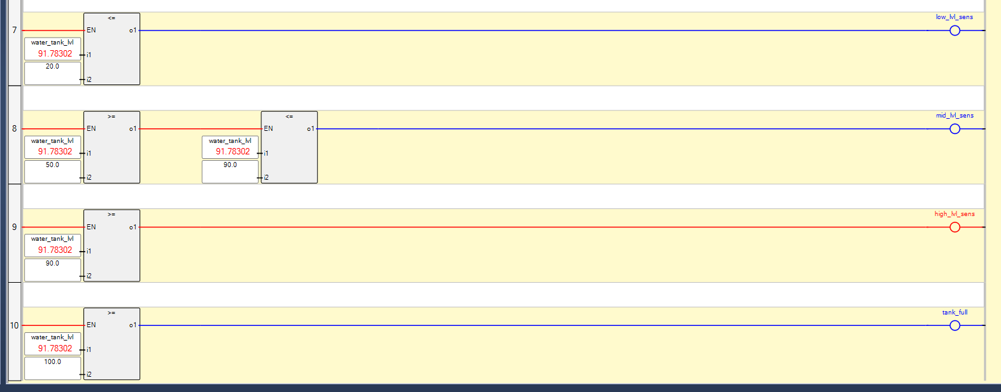
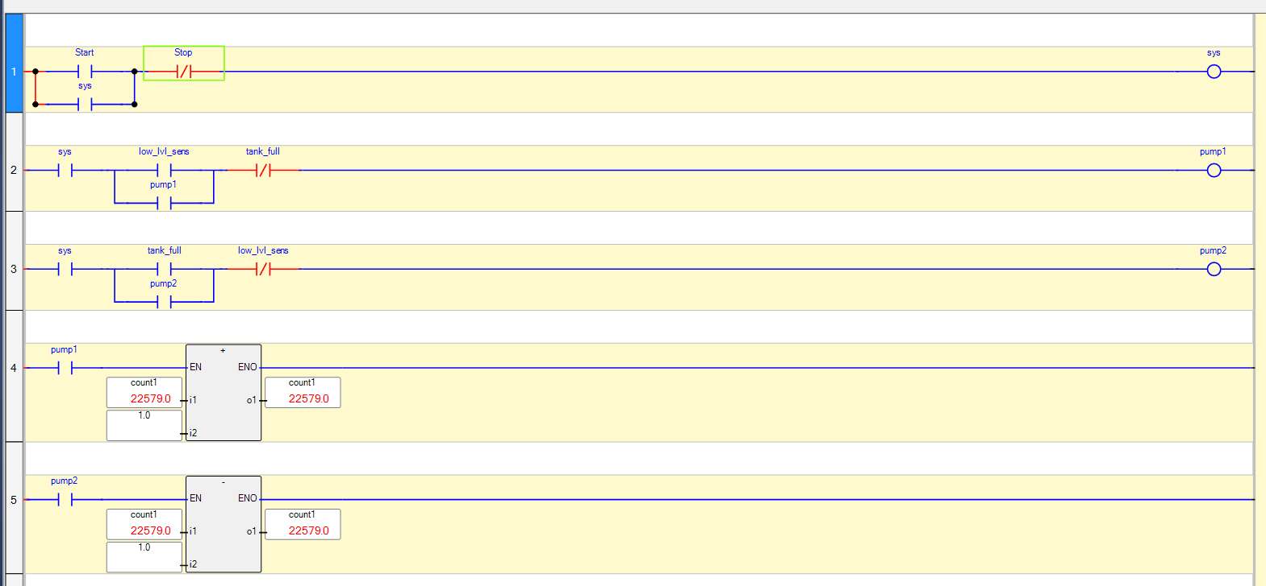
Discussion:
We first start the system using the “START” push button. Because the tank is empty, the “low_lvl_sens” is on, which latches “pump1” ON to start filling. As pump1 runs, the counter increases, and the SCALER block converts this to 0 to 100 scale equivalents. The comparator blocks turn on the low, mid, and high level sense outputs as the level rises. When it reaches 100, “tank_full” turns on, stopping pump1 and latching “pump2” ON to drain the tank. As the level drops to 20, “low_lvl_sens” stops pump2, and the filling cycle automatically repeats. The whole system can be turned off using the “STOP” push button.
Conclusion:
This lab successfully demonstrated the design and simulation of a virtual water tank filling and emptying process using Rockwell CCW. The experiment reinforced the practical application of fundamental PLC programming concepts, specifically addition and subtraction operation as water level up/down counters, the SCALER instruction converts these counts to equivalent 0 to 100 value, and Comparator instructions to create virtual process sensors.

